EXERCISE 1: MAPPING THE HOMEGUARD ECOSYSTEM (30 MINUTES)
1. System Entities (External to Boundary)
- Homeowner: Interacts with the system to send commands and receive status updates.
- Physical System: The hardware layer, including smart locks, sensors, and cameras that interact with the physical world.
2. Primary Processes
Your diagram should include four main logic centers:
- Manage Access & Authentication: Handles incoming credentials and validates permissions.
- Control Devices: Translates validated requests into physical actions for the hardware.
- Monitor Threats: Analyzes incoming sensor data to determine if an alert is necessary.
- Process Video Stream: Manages the flow of encrypted visual data.
3. Data Flows (Label these arrows clearly)
Connect your entities and processes using these specific flows:
- From Homeowner: Authentication Request and Access Code / PIN.
- From Physical System: Sensor Telemetry and Encrypted Video Feed.
- To Homeowner: Push Notification.
- To Physical System: Actuation Signal (Lock/Unlock).
- Internal Flows: Validation Result (from Access to Control) and Device State (from DB to Monitor).
4. Data Stores
- User Registry: Stores homeowner and guest credentials.
- Device Db: Maintains the current state of all hardware.
- User Events / Event & Video Logs: Historization of all system activity and media.

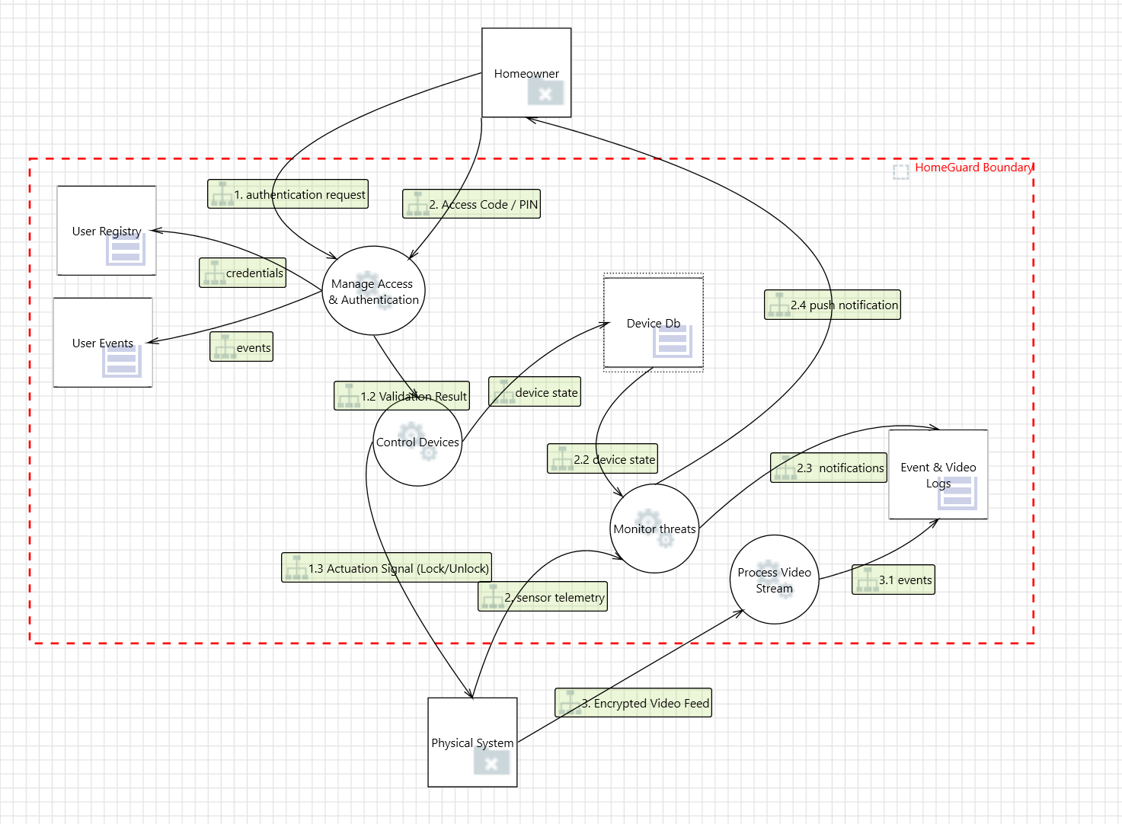

EXERCISE 2: Easy — DOM Injection Prevention
GitHub: https://github.com/kabartsjc/GMU-CYSE411.git

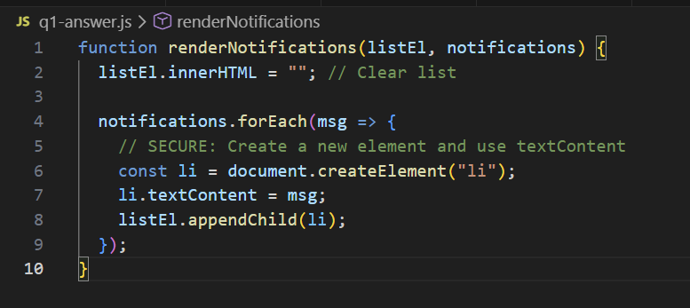
Explanation:
- The Vulnerability: The original code used .innerHTML. If a message contained <img src=x onerror=alert(1)>, the browser would parse that string as HTML and execute the JavaScript inside the onerror attribute. This is a DOM-based Cross-Site Scripting (XSS) attack.
- The Fix: Using .textContent tells the browser to treat the input strictly as plain text. Even if the string contains HTML tags, they will be displayed as literal characters (e.g., it will literally show "<b>" on the screen) instead of being rendered by the browser engine.

References:
- https://developer.mozilla.org/en-US/docs/Web/API/Element/innerHTML
- https://developer.mozilla.org/en-US/docs/Web/API/Node/textContent

EXERCISE 3: Medium — Input Sanitization & Logic
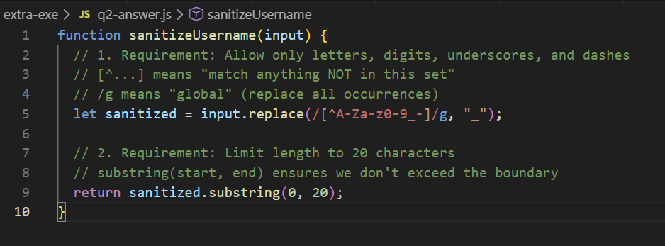
Explanation:
- The Vulnerability: The original code used a "blacklist" approach (checking only for <). Attackers can easily bypass this using other characters (like quotes, parentheses, or null bytes).
- The Fix: This solution uses a "Whitelist" strategy via Regular Expressions (Regex). By defining exactly what characters are allowed (A-Z, a-z, 0-9, _, -) and replacing everything else with an underscore, we ensure the output is always predictable and safe for the database and the UI.
- Length Constraint: Limiting the length is a defense-in-depth measure to prevent UI breakage or potential buffer-related issues in backend systems.
References:
- https://www.youtube.com/watch?v=M9d0otsXOEg
- https://instasafe.com/blog/whitelisting-vs-blacklisting-whats-the-difference/
- https://docs.icewarp.com/Content/IceWarp-Server/Administration-Nodes/Domains%20&%20Accounts/Simple%20RegEx%20Tutorial.htm
- https://www.rexegg.com/regex-quickstart.php
- https://regex101.com/

EXERCISE 4: Hard— Secure Async Fetch & Error Handling
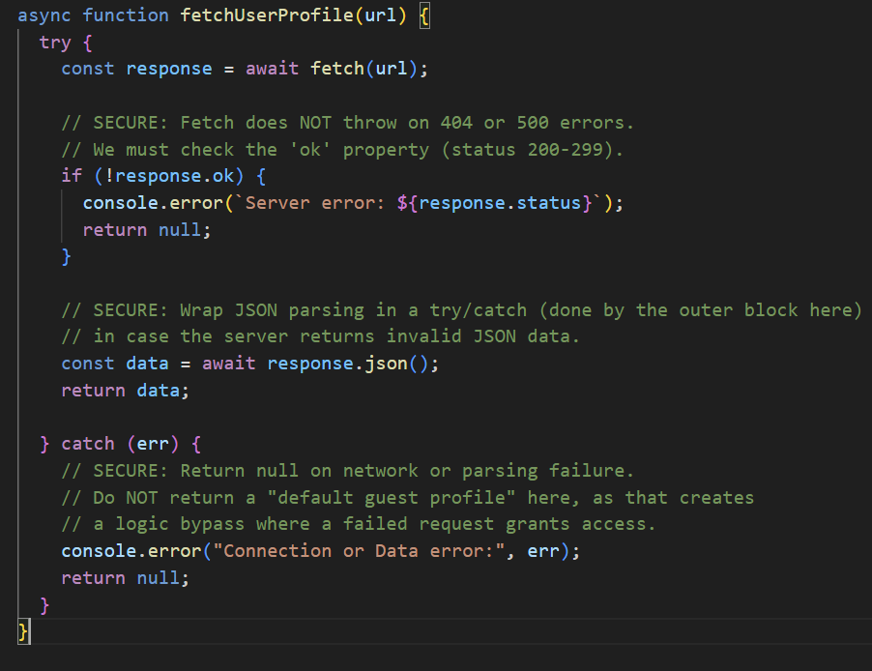
Explanation:
- The Vulnerability: In JavaScript's fetch() API, a request only "fails" (rejects the promise) if there is a network interruption. If the server returns a 404 Not Found or 500 Internal Server Error, fetch considers it a "success." Processing that response as valid data is a major security risk.
- The Fix:
  - Check response.ok: This ensures the HTTP status code is in the successful range (200-299).
  - Fail Safe: Instead of returning a "Guest" role when an error occurs, the function returns null. This forces the calling function to handle the lack of data properly, rather than accidentally granting "Guest" permissions to a user whose profile failed to load.
  - Error Handling: The try...catch block handles both network failures and cases where the server returns non-JSON content (which would make response.json() crash).

References:
- https://developer.mozilla.org/en-US/docs/Web/API/Background_Fetch_API
- https://developer.mozilla.org/en-US/docs/Web/JavaScript/Reference/Statements/try...catch
- https://developer.mozilla.org/en-US/docs/Web/JavaScript/Reference/Statements/async_function

